**VISVESVARAYA TECHNOLOGICAL UNIVERSITY**

**BELAGAVI, KARNATAKA**



A Mini Project Report

**(Fifth Semester)**

On

**“Parking Management App for Android”**

Submitted in the partial fulfillment for the requirements for

the conferment of degreeof

**BACHELOR OF ENGINEERING**

In

**INFORMATION SCIENCE AND ENGINEERING**

By

**Mr. PRAJWAL R USN: 1BY18IS084 Mr. Prashanth R USN:1BY18IS089 Mr. Raghavendra K M USN: 1BY18IS093 Ms. Sugandha Sinha USN: 1BY18IS119**

Under the guidance of

**Mrs. Dr Surekha K.B. Asst. Professor**



**2020-2021**

**VISVESVARAYA TECHNOLOGICAL UNIVERSITY**

**BELAGAVI, KARNATAKA**

**1.5 Android Architecture**

Android architecture contains different number of components to support any android device needs. Android software contains an open-source Linux Kernel having collection of number of C/C++ libraries which are exposed through an application framework services. Among all the components Linux Kernel provides main functionality of operating system functions to smartphones and Dalvik Virtual Machine (DVM) provide platform for running an android application.

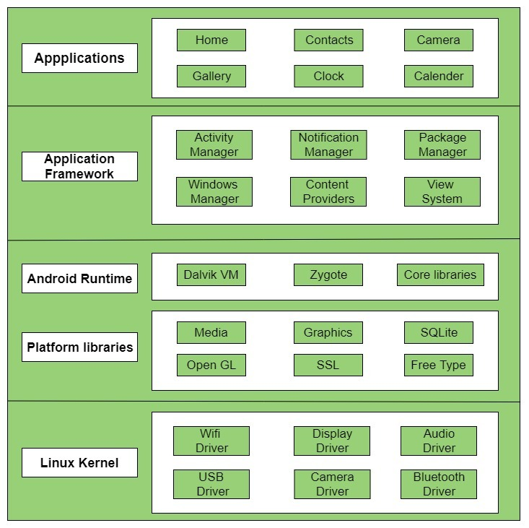

fig 1.5: Android Architecture

**1.6 Android Application Components**

Application components are the essential building blocks of an Android application. These components are loosely coupled by the application manifest file AndroidManifest.xml that describes each component of the application and how they interact.

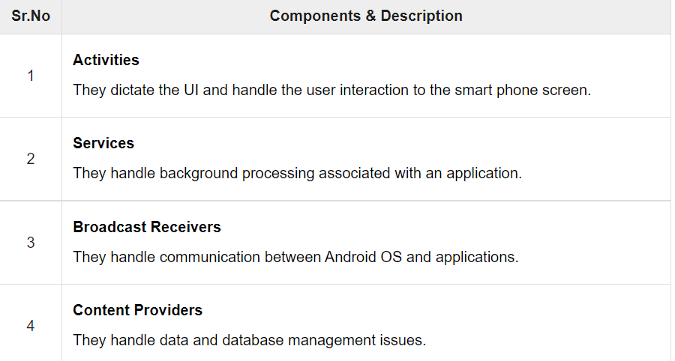

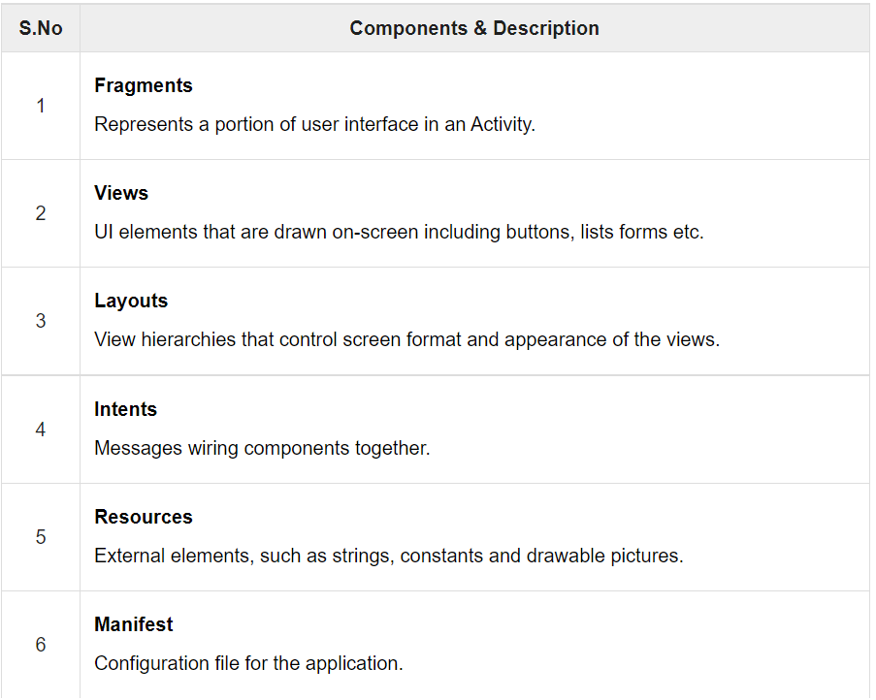

Fig 1.6 Android components

**1.7 Problem Statement**

With the increasing number of vehicles and the decreasing efficiency of modern busy parking lots, major problems which we people are facing is:

1. Valuable time wasted from inconvenient and inefficient parking lots.
2. More fuel consumed while driving around parking lots, leading to CO2 emissions.
3. Potential accidents caused by abundance of moving vehicles in disorganized parking lots.

Therefore, there is a need to develop an affordable system which solve the problem and obtain the information about the parking lot on real time.

**1.8 Objectives**

* To develop an intelligent, user friendly automated car parking system which reduces the manpower and traffic congestion.
* To improve the performance and satisfy the need of free parking lot.
* To reduces the time wastage in finding the vacant parking lot.

**1.9 Project Applications**

**List all the figures/tables/images used**

Fig 1.5 Android architecture

Fig 1.6 Android components